Batch: A3 Roll No.: 1911034

Experiment / assignment / tutorial No. 04

Grade: AA / AB / BB / BC / CC / CD /DD

Signature of the Staff In-charge with date

TITLE :An Array of Objects

AIM : Write a program which accepts information about n no of customers from user .Create an array of objects to store account_id ,name,balance.
Your program should provide following functionalities
1.To add account
2.To delete any account detail
3.To display account details.
_____________________________________________________________________
Expected OUTCOME of Experiment:

CO2:Solve problems using Java basic constructs (like if else statement, control structures, and data types, array, packages, collection class).

Books/ Journals/ Websites referred:

1. Ralph Bravaco , Shai Simoson , “Java Programing From the Group Up” Tata McGraw-Hill.

2.Grady Booch, Object Oriented Analysis and Design .
_____________________________________________________________________
Pre Lab/ Prior Concepts:

Arrays of Objects:
Unlike traditional array which store values like string, integer, boolean, etc. array of objects stores objects. The array elements store the location of reference variables of the object.

For example:

class Student {
int rno;
String name;
float avg;
}
Student(int r, String name, float average)
{
rno=r;
this.name=name;
avg=average;
}
Student studentArray[] = new Student[n];

- The above statement creates the array which can hold references to n number of Student objects. It doesn't create the Student objects themselves. They have to be created separately using the constructor of the Student class. The studentArray contains n number of memory spaces in which the address of n Student objects may be stored.
for ( int i=0; i<studentArray.length; i++) {
studentArray[i]=new Student(r,name,average);
}
The above for loop creates n Student objects and assigns their reference to the array elements. Now, a statement like the following would be valid.
studentArray[i].r=1001;
.
Class Diagram:

CLASSES
- class Exp04
- class BankAcc

METHODS:
Belonging to Class Exp04:
- public static void main(String args[])
Belonging to class BankAcc:
- public int getData();
- public void showData();
VARIABLES:

Belonging to main method():
int i,num,ch,c,t=0,n1,j,ch1;
String n;
float b;
Instance Variables belonging to class BankAcc:(they belong to each object of the array of objects BankAcc[] declared in the main() method.
public String name;
int id;
float bal;
Variables in getData():
String n1;
float b1;

Implementation details:
import java.util.*;
class Exp04{
public static void main(String[] args) {
System.out.println("Hello world!");
int i,num,ch,c,t=0,n1,j,ch1;
String n;
float b;

Scanner sc = new Scanner(System.in);

BankAcc acc[] = new BankAcc[100];//creating reference to 100 BankAcc objects stored in the array of objects
while(true)
{
System.out.println("Enter 1 of the following");
System.out.println("1 to create account");
System.out.println("2 to delete an account");
System.out.println("3 to display all account details");
ch= sc.nextInt();
switch (ch)
{
case 1:
{
System.out.println("Please enter the Account ID");

num = sc.nextInt();
acc[t] = new BankAcc();//creating the actual object of the array of objects
c = acc[t].getData(num);// calling getData() to initialize the values
if(c==1)
{
t++;
System.out.println("Account successfully created");
}
}
break;
case 2:
{
if(t==0)// in case the array of objects is empty after deleting all acounts
{
System.out.println("No accounts left to delete. Try again");
continue;
}
else
{
System.out.println("Enter the ID number of the account you wish to delete");
n1 = sc.nextInt();
int flag =0;
for(i=0;i<t;i++)
{
if(n1==acc[i].id)
{ flag=1;
for(j=i;j<(t-1);j++)
{
acc[j] = acc[j+1];// for shifting array elements after the deleted account one place forward
}
System.out.println("Account successfully deleted");
t--;
break;
}
}
if(flag==0)
{
System.out.println("Account not found, please try again");
continue;
}

}
}
break;

case 3:
{if (t==0)
{
System.out.println("No accounts left to display, please create a new account first");
}
else
{System.out.println("Enter 1 to display sorted according to Account number or 2 to display in increasing order of balance left");
ch1 = sc.nextInt();
switch(ch1)
{
case 1:
{
for(i=0;i<t;i++)
{
System.out.println("Account " +(i+1));
acc[i].showData();
}
}
break;

case 2:
{ BankAcc obj = new BankAcc();//BankAccount obj is used as a temporary variable to sort the objects
for(i=0;i<t;i++)
{//following bubble sort
for(j=0;j<t-i-1;j++)
{
if(acc[j].bal>acc[j+1].bal)
{
obj = acc[i];
acc[i]=acc[i+1];
acc[i+1]=obj;
}
}
}
for(i=0;i<t;i++)
{
System.out.println("Account " +(i+1));
acc[i].showData();
}

}
}

}
}

}

}
}
}

class BankAcc
{
public String name;
int id;
float bal;//these variables belong to every object in the array of objects declared in class Exp04

public int getData(int n)//for instantiating the values of each object
{String n1;
float b1;
Scanner s1 = new Scanner(System.in);
this.id = n;
System.out.println("Enter the name");
n1 = s1.next();
this.name = n1;
System.out.println("Enter the balance");
b1 = s1.nextFloat();
this.bal = b1;
return 1;
}

public void showData()// used to display the characteristics of each object.
{
System.out.println("Account ID: " +id);
System.out.println("Name: " +name);
System.out.println("Balance left:" +bal);
System.out.println("------------");

}

}
Output:

Case1: adding a few accounts :
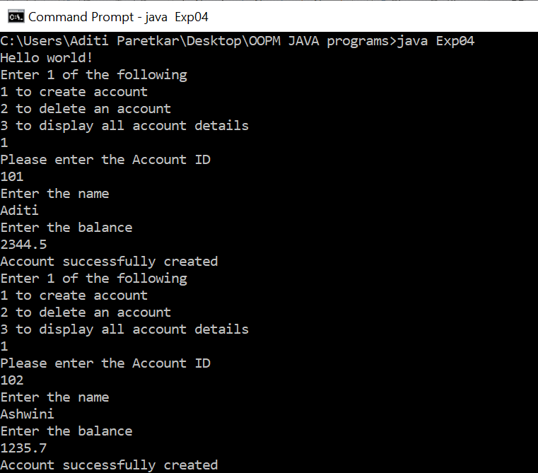

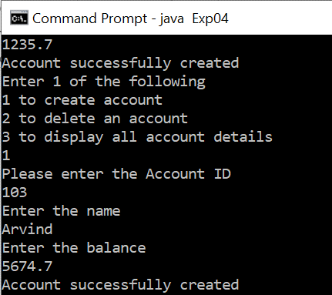

Case 2 : Displaying All Accounts Details( sorted according to the order of the increasing account number)

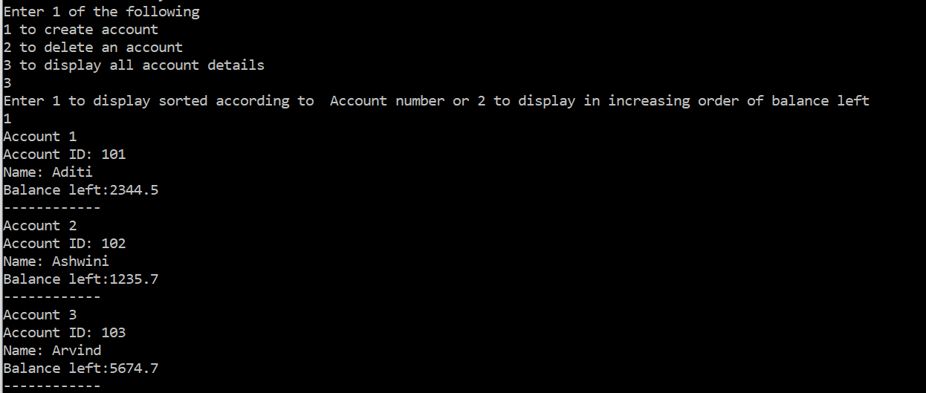

Case 3: Displaying in order of increasing balance left(additional implementation):
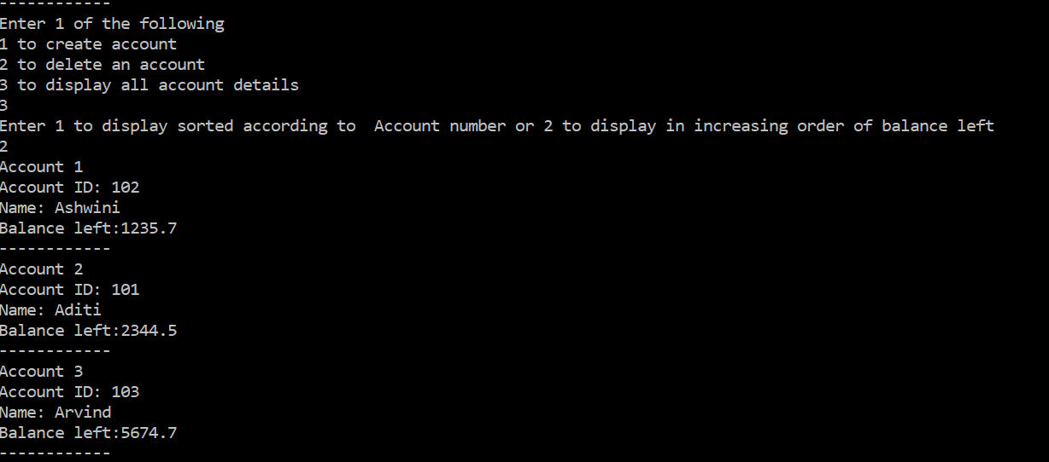

Case 4: Trying to delete an account with invalid ID
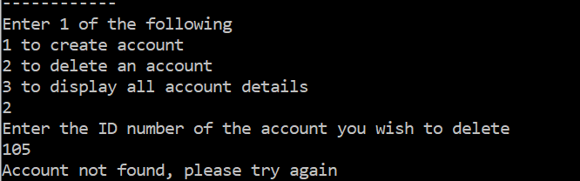

Case 5: Deleting accounts one by one and displaying

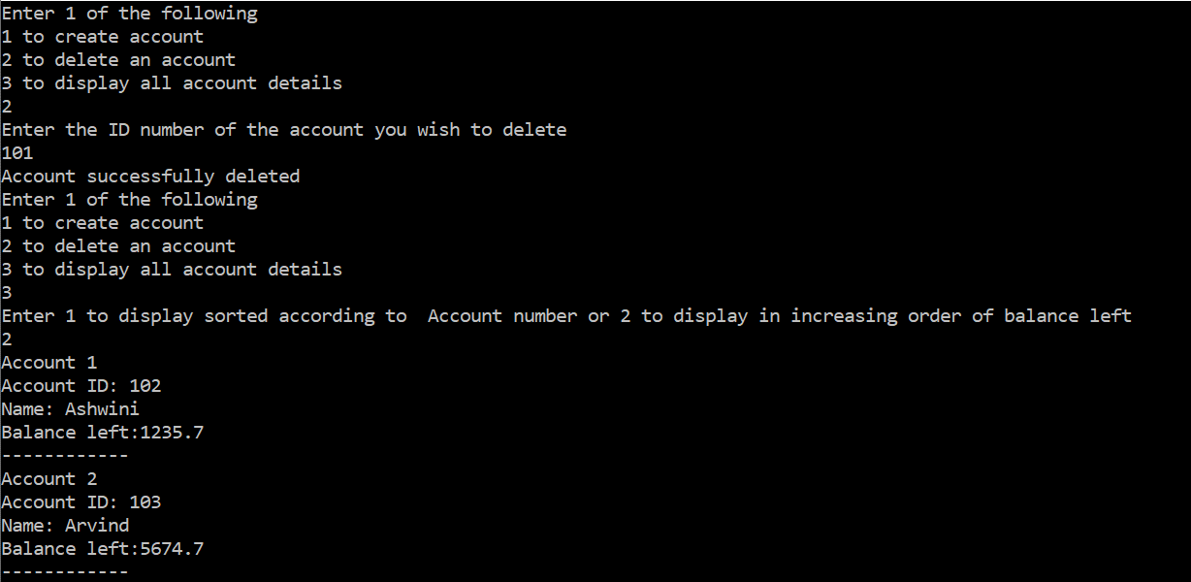

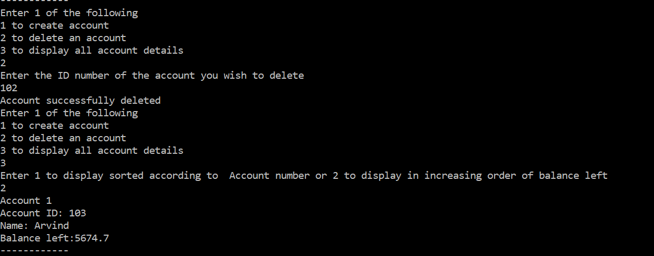

Case 6: after deleting the last account , when we try to display all the accounts left in the array , it will show us an error:
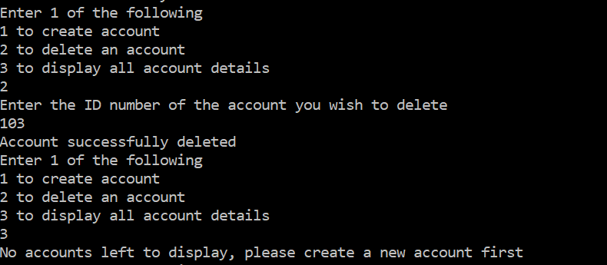

Conclusion: In this experiment we have learnt the following :
      - An array of objects in java, is an array that has objects as it’s elements.
      - We have learnt how to initialize (declare) an array of objects in java and how to allocate memory to each individual object using the constructor of that class, to which the objects belong
      - We have learnt how to access the individual data members of the objects belonging to the array and sort them according to the salary (data member)

Post Lab Descriptive Questions

Q.1 If an array of objects is of size 10 and a data value have to be retrieved from 5th object then ________________ syntax should be used.
a)Array_Name[4].data_variable_name;
b)Data_Type Array_Name[4].data_variable_name;
c)Array_Name[4].data_variable_name.value;
d) Array_Name[4].data_variable_name(value);
Ans:
a)Array_Name[4].data_variable_name;

Q.2)The Object array is created in _____________________
a)Heap memory
b) Stack memory
c) HDD
d) ROM
Ans) a) Heap Memory
Date: Signature of faculty in-charge

